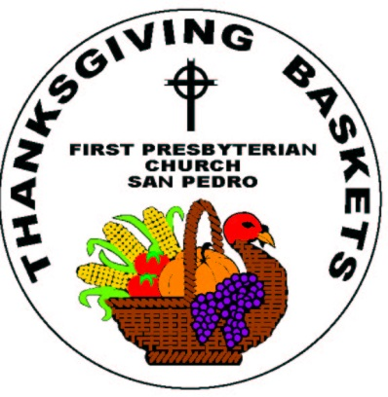**FIRST PRESBYTERIAN CHURCH OF SAN PEDRO**

**731 S. Averill Avenue, San Pedro, CA 90732**

**310-832-7597 www.FirstPresSanPedro.org**

Our Church leads a community effort to provide Thanksgiving food “baskets” to families in the Harbor area. A “basket” consists of a box or bag of non-perishable items and a gift card for fresh food so the family can prepare and serve its own special holiday meal. Recipients must be referred by a school or community agency, based on need. Please fill out the following to apply:

**Thanksgiving Basket Family Application**

Head of Household’s Name _________________________________________________________

Children’s Names & Ages ___________________________________________________________

Household Address ________________________________________________________________

City ___________________________ Zip Code ___________

Contact Phone # _____________________ Email _____________________________________

**PICK UP a box at the church** (731 S. Averill Avenue, San Pedro).You must bring an ID, utility bill, or our confirmation email.

**Pick up time (CHOOSE ONE OPTION):**

□ Sunday, November 19th between Noon and 4pm

Join us for lunch Noon-2pm, refreshments and family activities available 2-4pm

□ Monday, November 20th between 9am and 2pm

□ Tuesday, November 21st between 9am and 2pm

Boxes not picked up by Tuesday at 2pm will be donated to San Pedro Meals on Wheels.

**FOR OFFICE USE ONLY**

**Referring Agency or School_______________________________________________**

**Preferred Language (circle one): English Spanish Other: ______________**

Status:

Application Number